Adding a New User to Providerlink for Legacy Login

- Login to https://login.providerlink.healthcare.covisint.com
- Navigate to the Setup menu on the grey toolbar 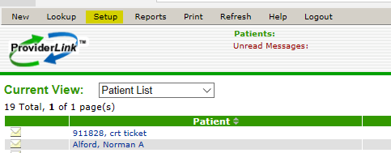
- Click on the Users menu 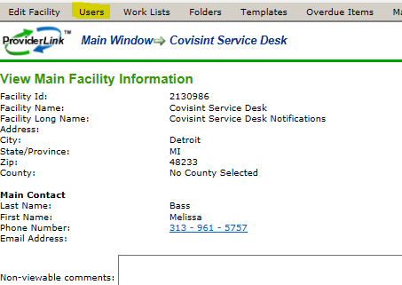
- Click on the New menu 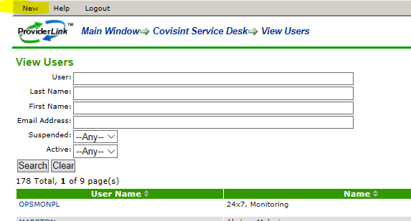
- Fill in the following information: last name, first name, phone number, email address, user name and password. Select a user role, facility and mailbox. Click Save 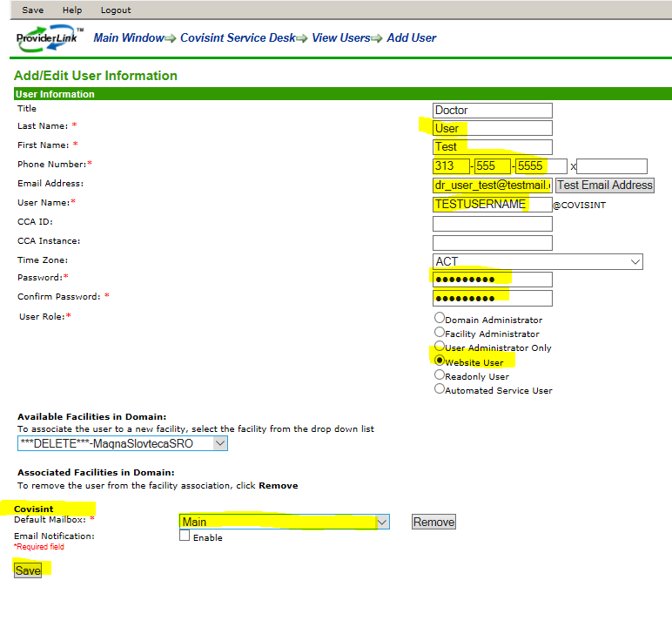
- The user will then be able to login at https://login.providerlink.healthcare.covisint.com.
