- Admin Action: Invite the user to register for a Covisint ID.
  - You can do this from the Covisint Healthcare Portal (https://portal.healthcare.covisint.com/web/portal/home), from the drop down select MY PROFILE.
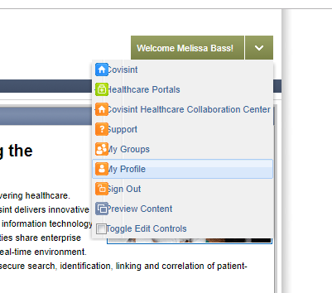
  - Click on Administration > Invite > Invite Users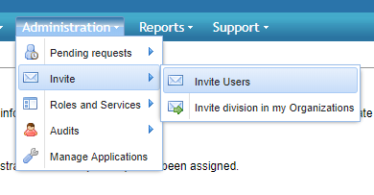
  - Enter the email addresses for the users you wish to invite. Click “send invitation” 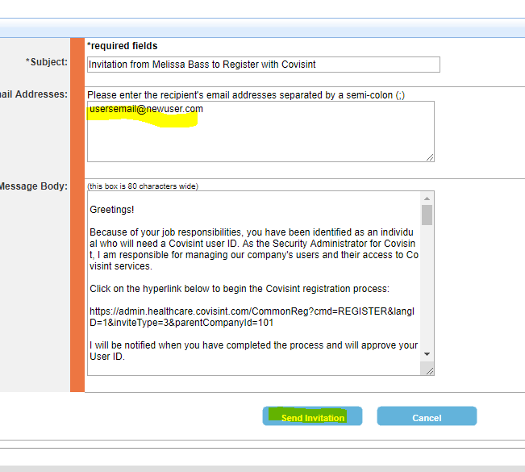
- User Action: User Covisint Account Creation
  - The user will click the link in the invitation email 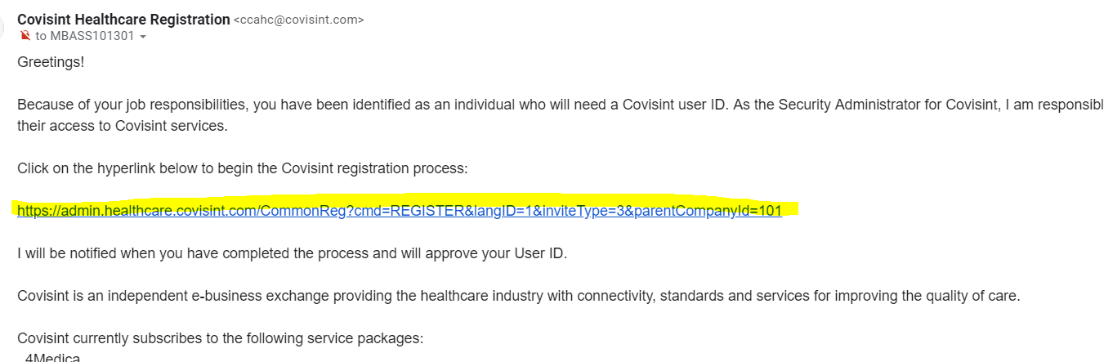
  - The user will fill out the registration form to create a profile and Covisint ID and password. 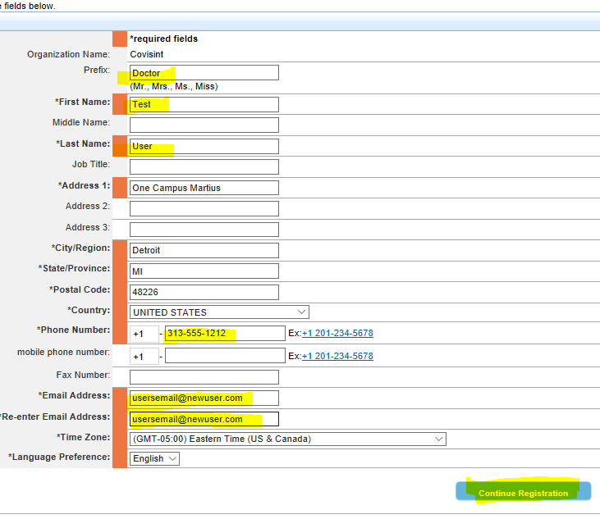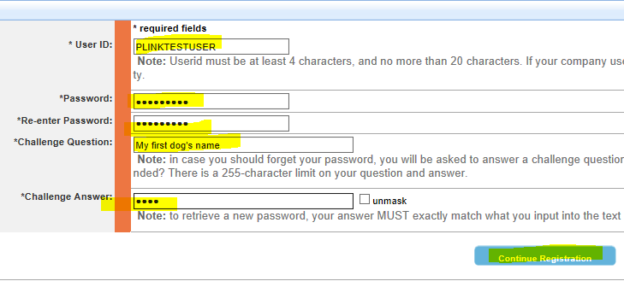
  - Select the “Providerlink” Service Pacakge during registration 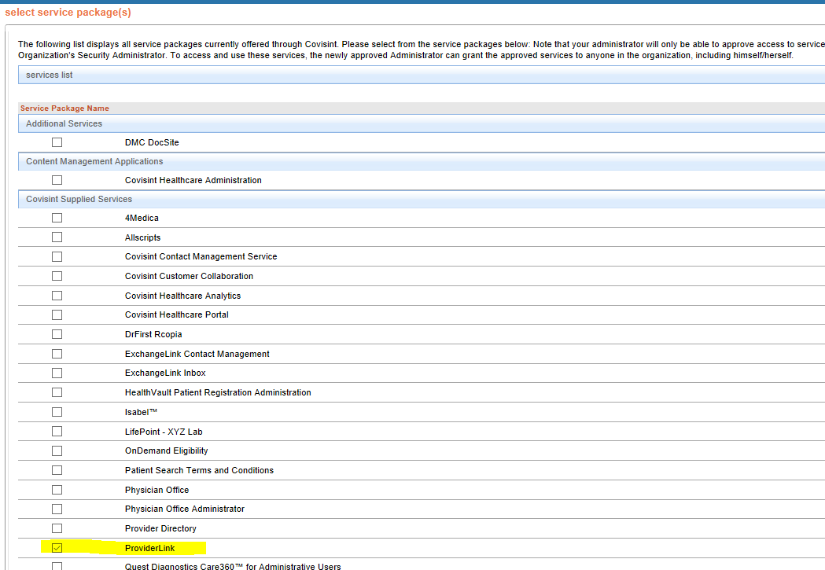
  - Agree to terms and conditions 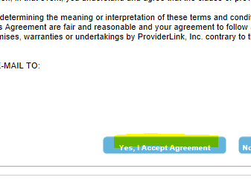
  - Submit registeraton 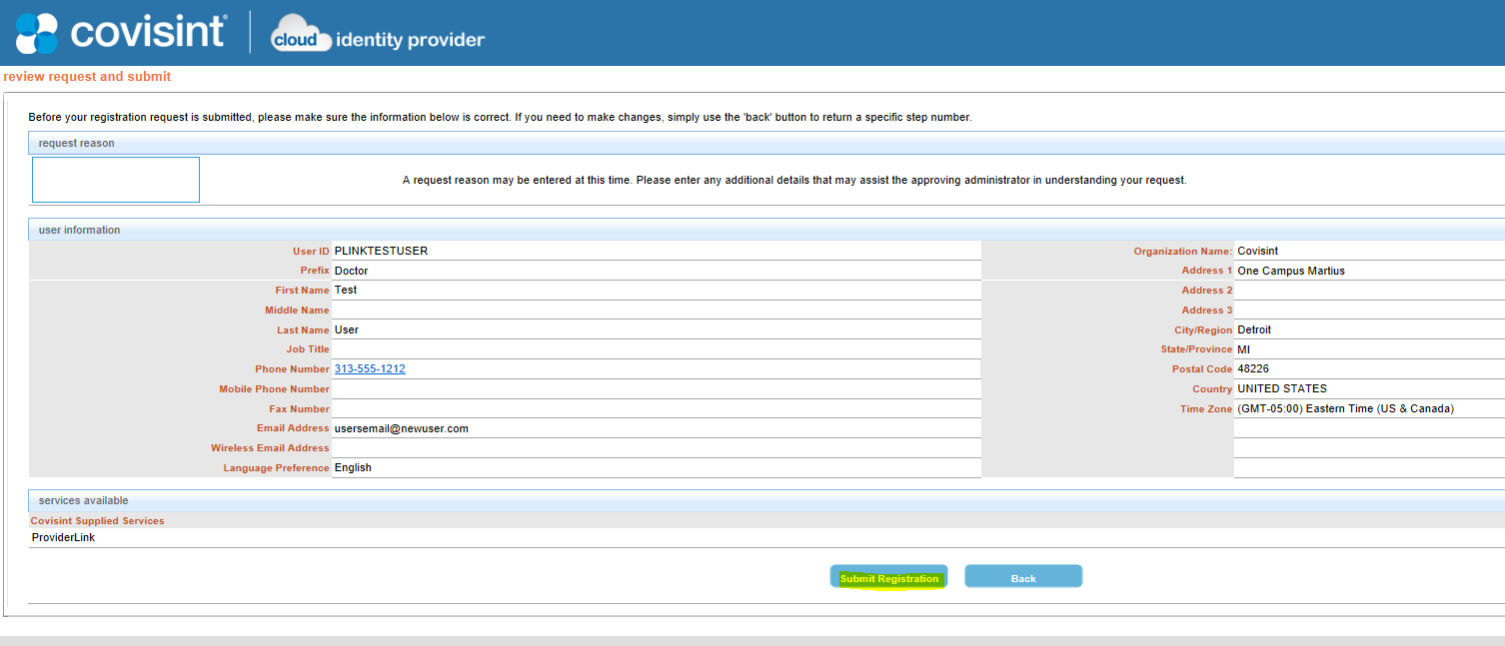
  - If the process is sucessful, the user will see a confirmation 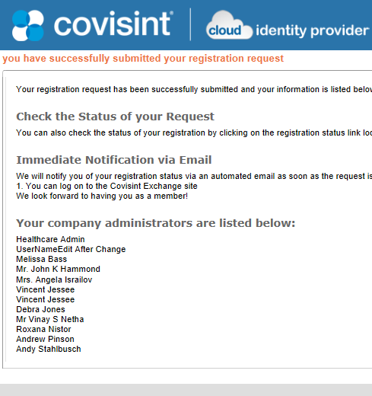
- Admin Action: User Covisint Account Approval
  - Navigate to Administration > Pending requests > User Requests 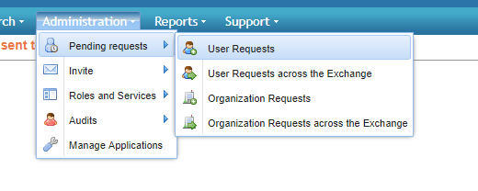 OR Click on the link in the email notification that announces thet user has reistered 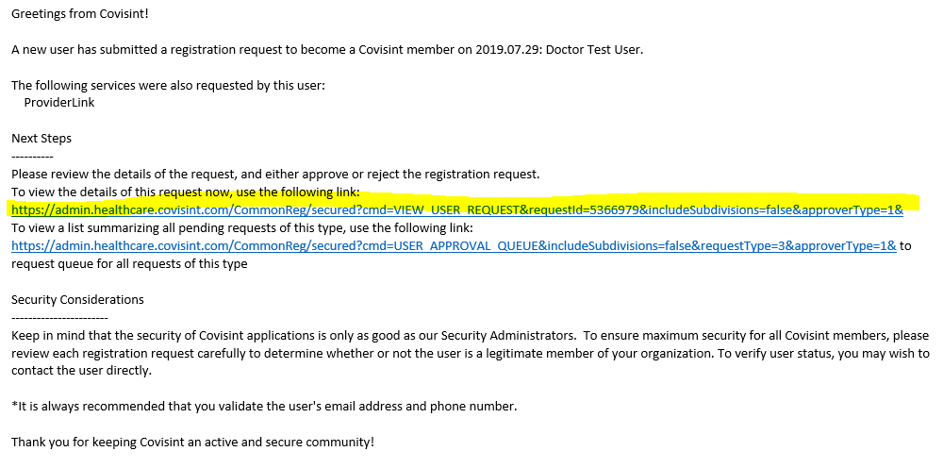
  - Click the paper icon next to the request to view it
  - Select the Approve radio buttons and click on the Submit Decision button 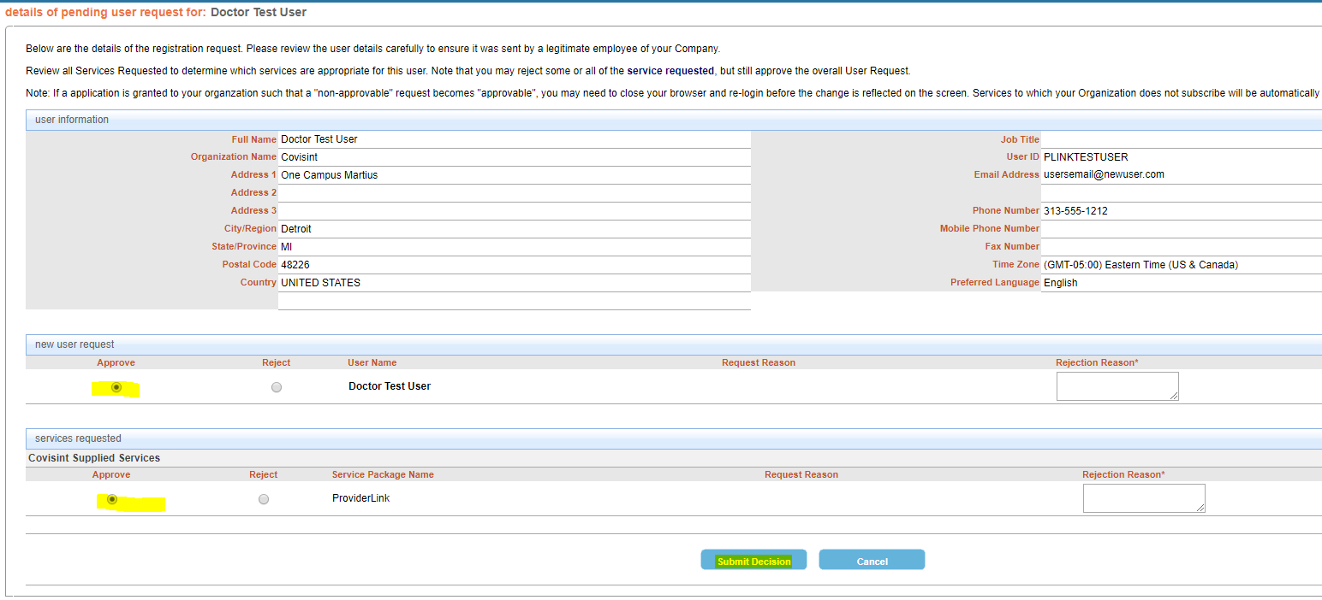
  - The user will be notified by email that the request has been approved
- User Action: Login into Providerlink
  - The user should login at https://sso.healthcare.covisint.com with his or her new ID and password 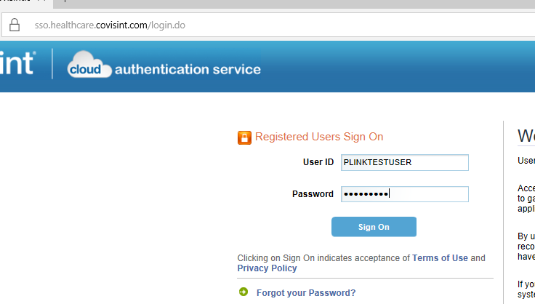
  - Launch the Providerlink application from the Secured Applications list. NOTE: Until this is done the user’s ID will NOT appear in the Providerlink application! 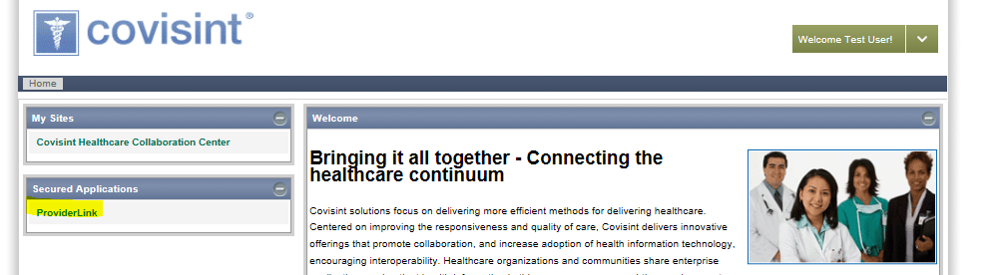
  - User will be presented with terms and conditions, they will need to click YES to continue 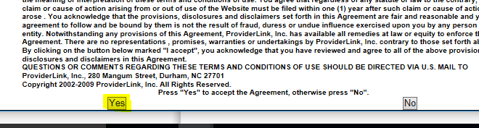
  - User may be presented with a Splash screen displaying Providerlink news and announcements. Click the “Proceed to Application” button 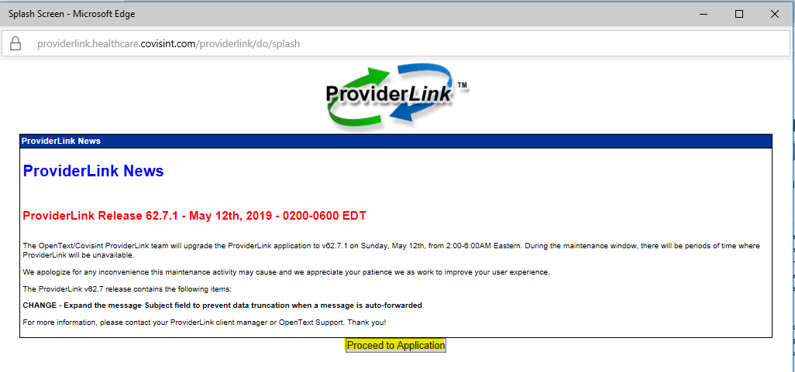
  - The user will get an error message tell him or her that he or she cannot be logged in. 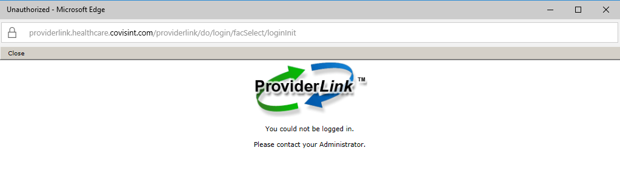
- Admin Action: Link Providerlink Profile to a Facility and Mailbox
  - Login to Covisint and launch Providerlink
  - Click on the Setup opton on the grey toolbar 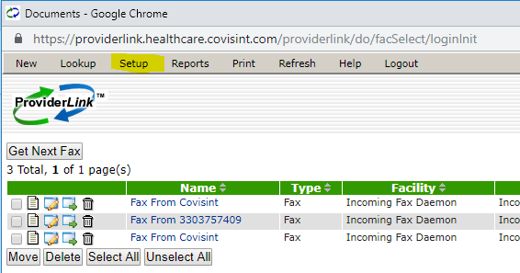
  - Click on the Users option 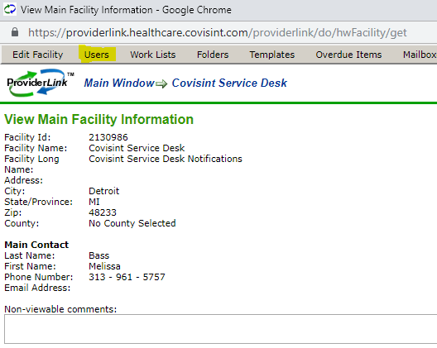
  - Search for the user, then click on the user name to open the use’s Providerlink profile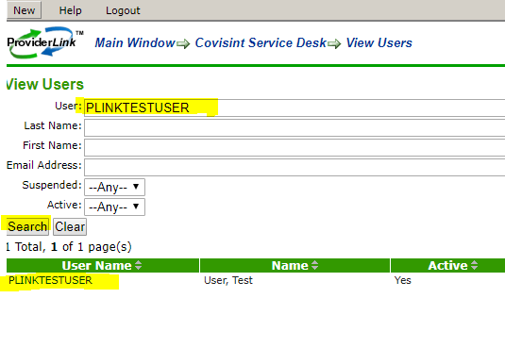
  - Select a role, facility and mailbox for this user. The user can only have one role; most users use the Website User role, however, if the user nees admin rights, then the facility or domain admin roles can be given. Click the save button.
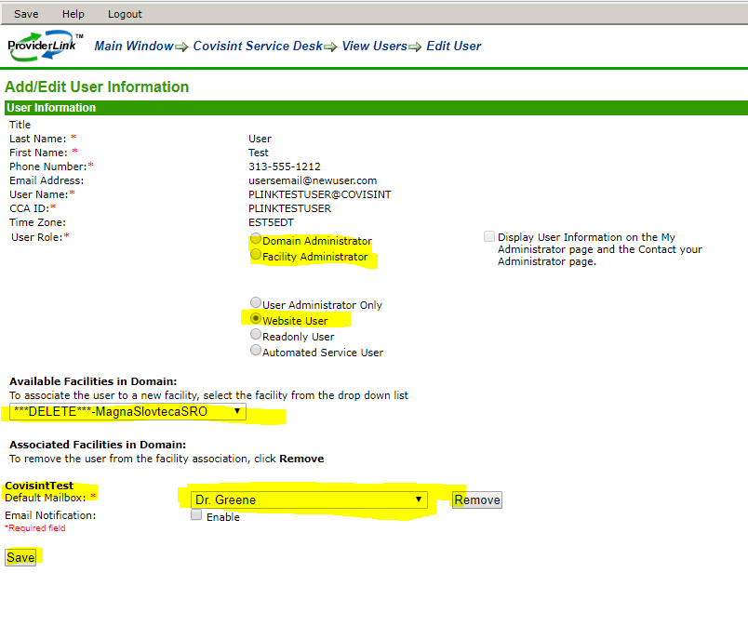
- Userr Action: The user should now be able to login to Providerlink sucessfully and use the application.

